1. First visit.

Assessment of client's condition.

Name: |  | Date of birth:

1.1. the image
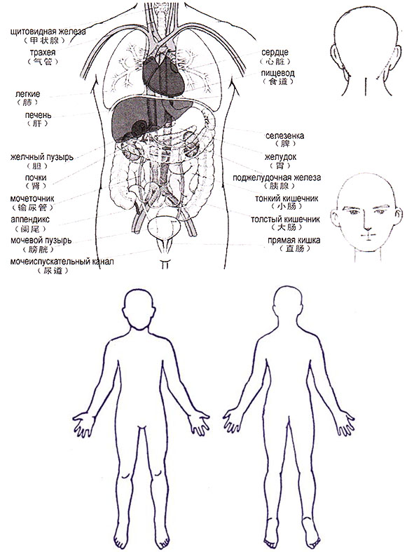
thyroid

trachea
lungs
liver
gallbladder
kidneys
ureter
appendix
bladder
urethra
heart
esophagus
spleen
stomach
pancreas
small intestine
colon
rectum

1.2. customer complaints

1.3. Diagnosis from the Western medicine point of view (if any, see the documents in the application)

1.4. Study plan. Medications. Designated specialists.

Date: |  | Specialist’s signature:

