Application №1

Date: |  | Session number:

1.1. the image
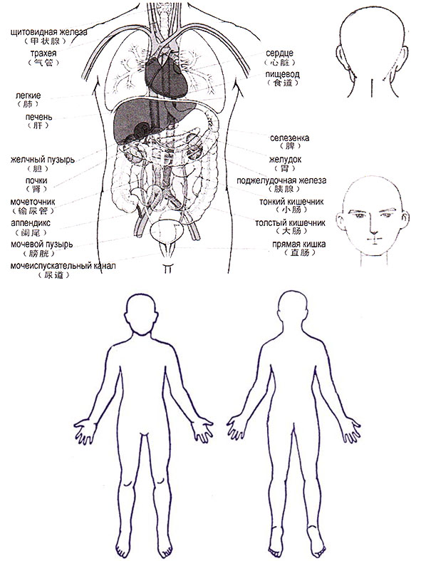
thyroid

trachea
lungs
liver
gallbladder
kidneys
ureter
appendix
bladder
urethra
heart
esophagus
spleen
stomach
pancreas
small intestine
colon
rectum

